Devki Mahaveer Homoeopathic Medical College & Research Hospital
Farathiya, Garhwa, Jharkhand.

Capability enhancement and development schemes employed by the Institution for students:
1. Soft skill development
- The soft skills are skills people use to communicate, solve problems, lead and think creatively and these are used in personal and professional life.
- The soft skills help to organize, plan, and manage the changes during the course of practice.
- The combination of technical expertise and soft skills is very important for patient management and Homoeopathy practice.
- Now-a-days, soft skills are considered as important tool for the success of professional practice.
- It includes team-work, communication, patient relationships management, problem solving and achievement of orientation skills.
- Thus, soft skills include networking, enthusiasm, professionalism, communication skills, team-work and problem solving and critical thinking.
Devki Mahaveer Homoeopathic Medical College & Research Hospital focuses on these elements and conducts orientation programs annually.

Utprerana – I BHMS orientation program
Clinical orientation program – III BHMS students program

Language and communication skill development

As a part of regular curriculum, the institution has included English language classes for I BHMS students to enhance their communication and writing skills.
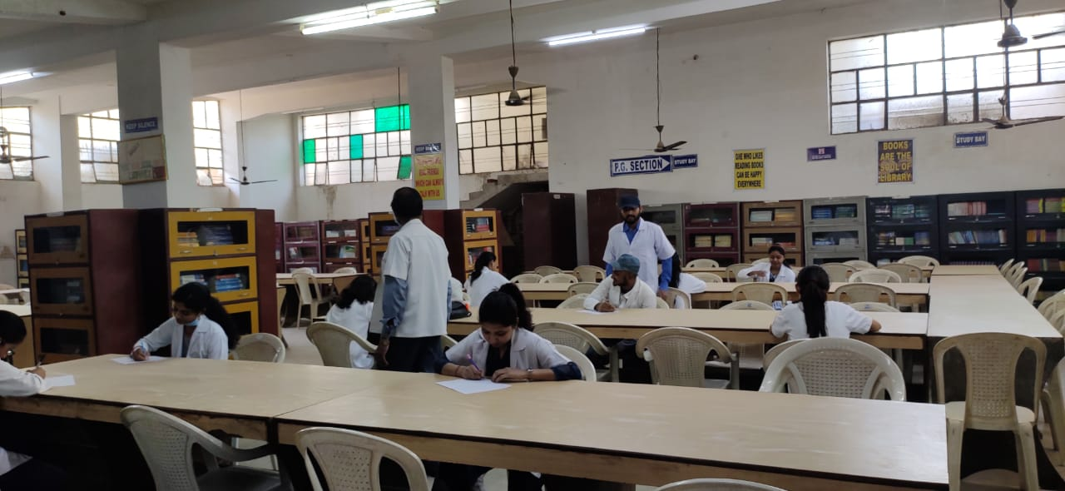
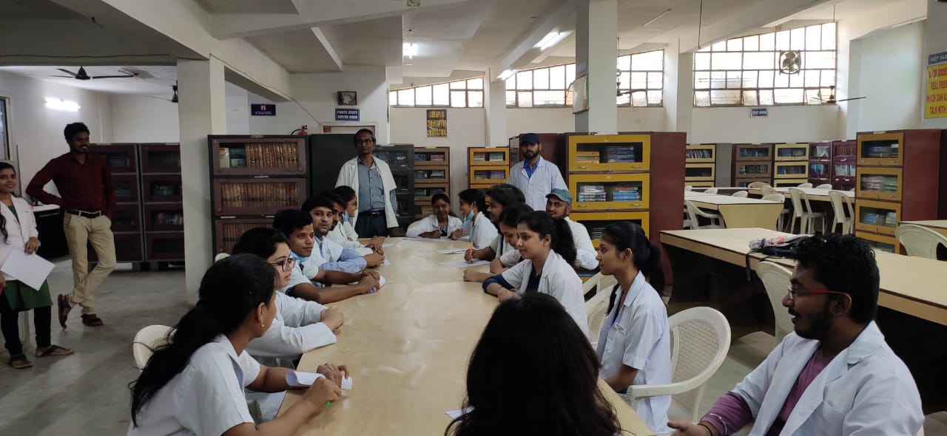

Yoga and wellness
The institute has set up a separate yoga and wellness centre in the campus where the students are trained and educated under the guidance of a professional yoga instructor Dr. P.D. Tiwari

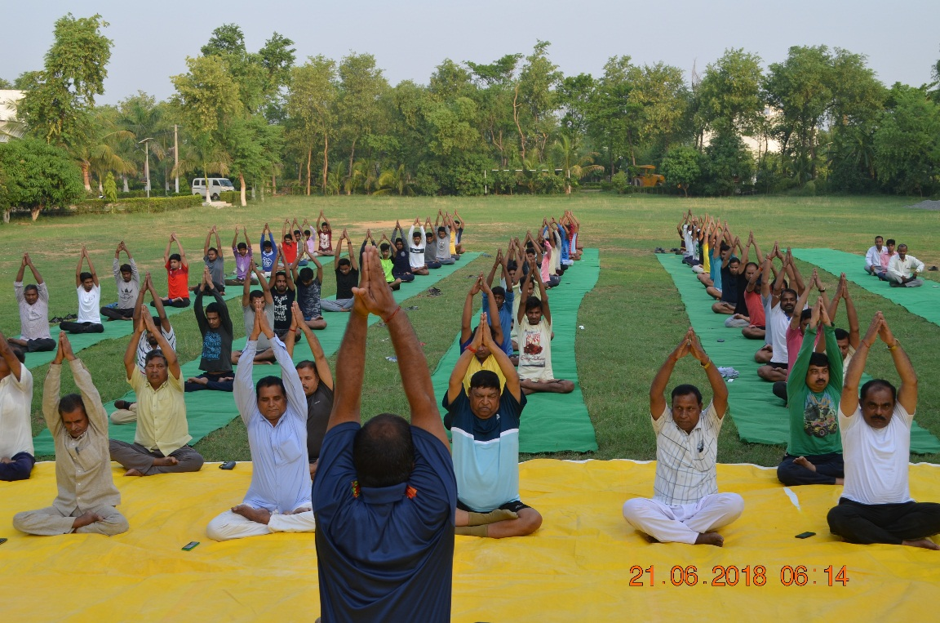
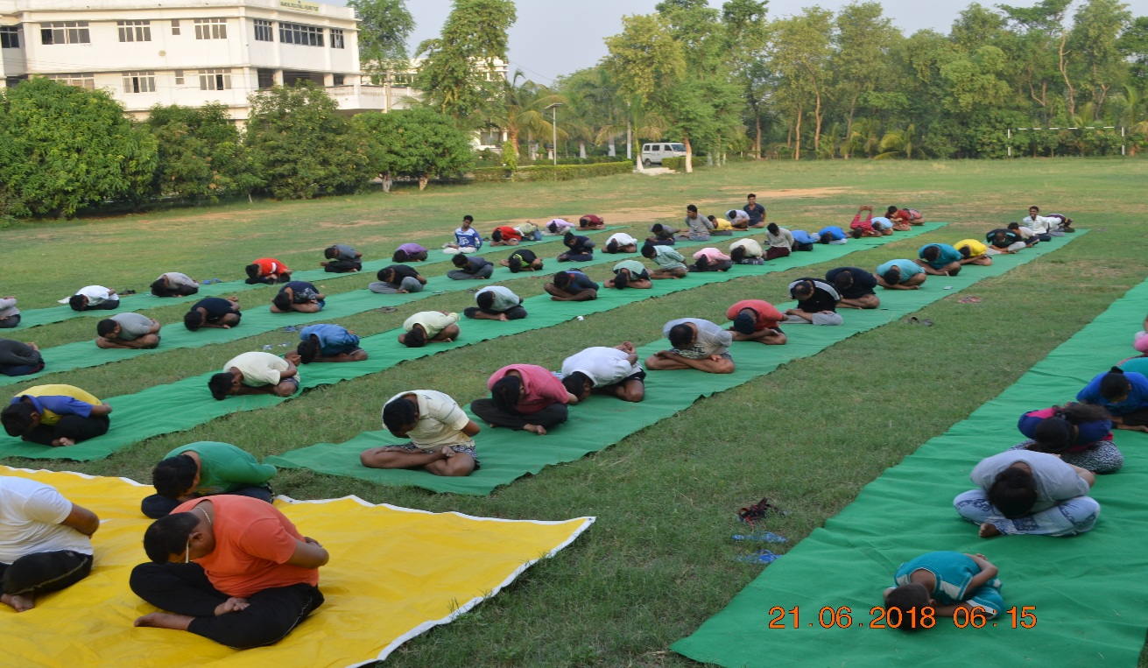

Analytical skill development
Analytical skill or critical thinking in homoeopathy is very much required while dealing with the patients, abiding by this the institute has implemented case-based learning program for the under graduate course.
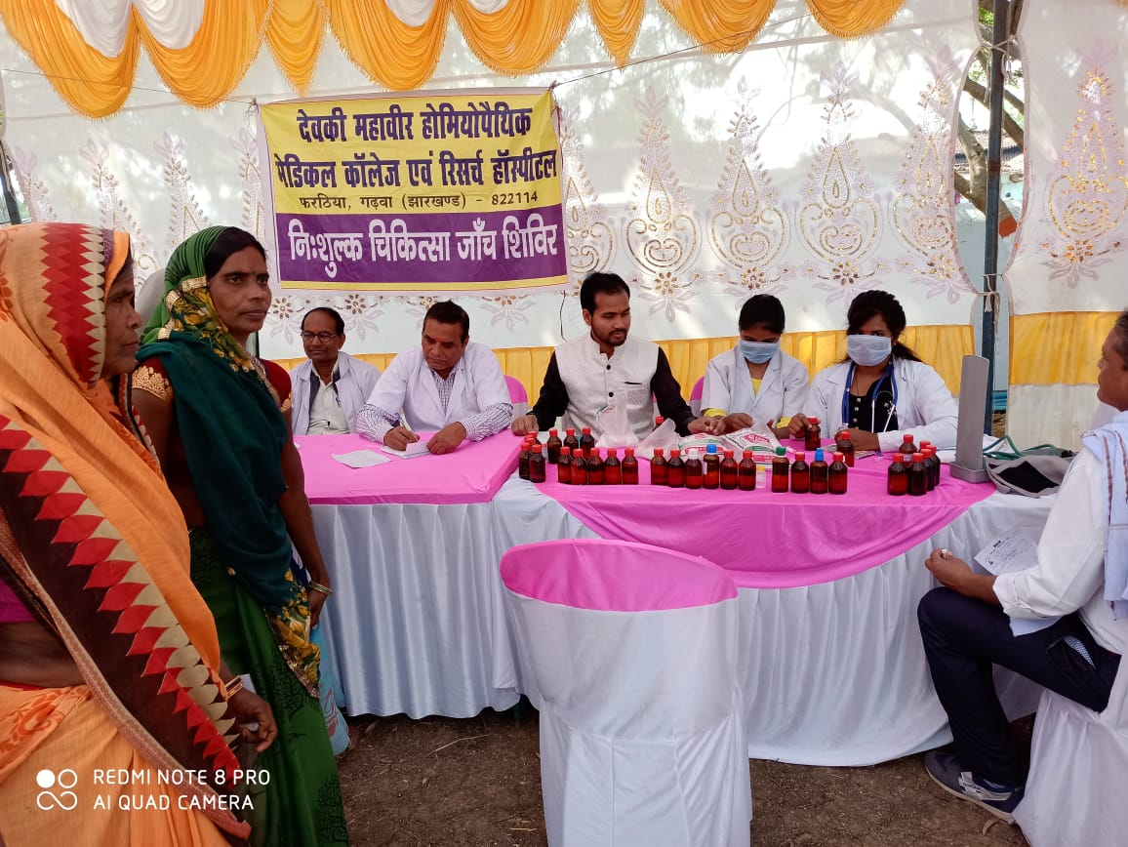
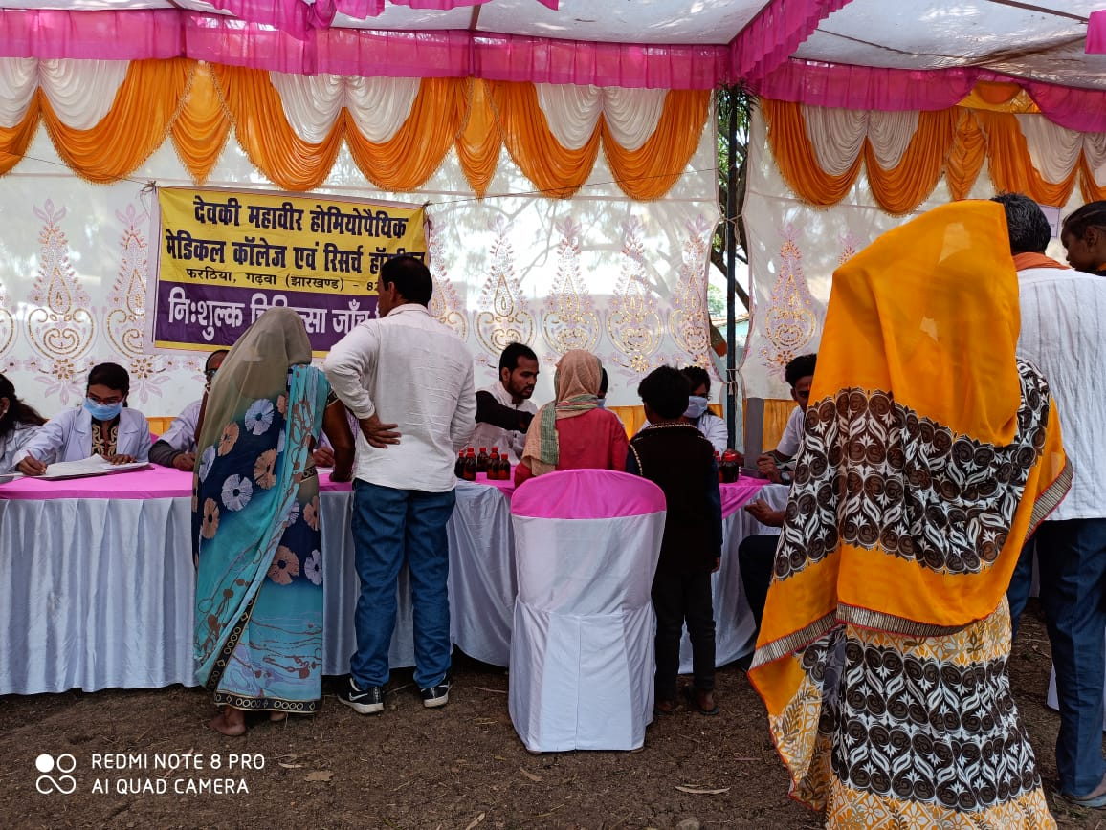

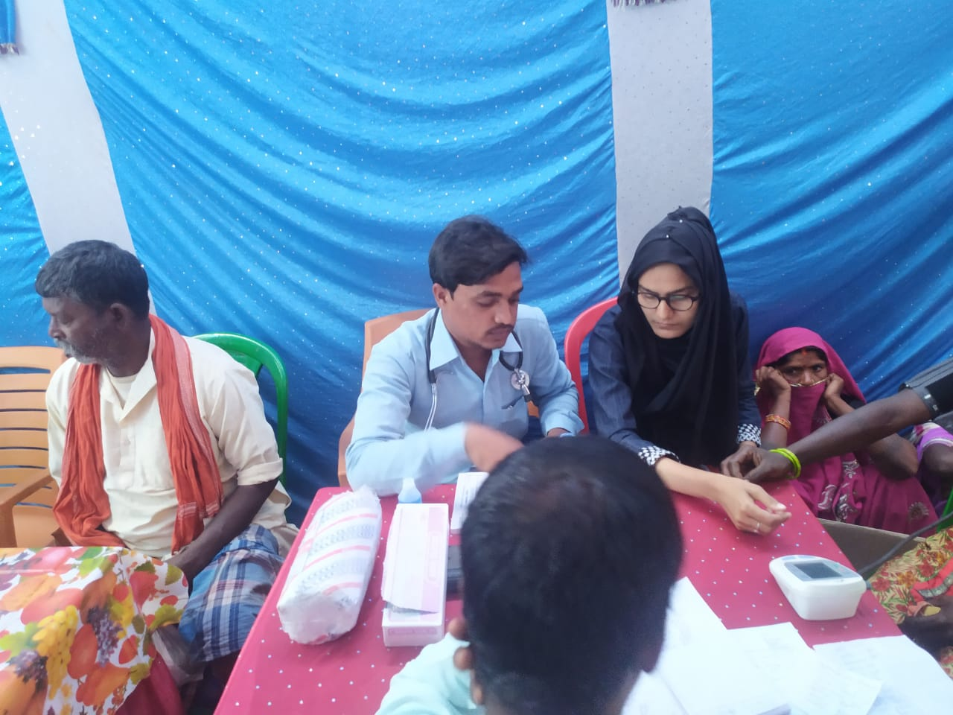

Human value development
The institution is attaining the services of sister concern college Dinesh Educational center in providing training for our BHMS students to develop their human values.

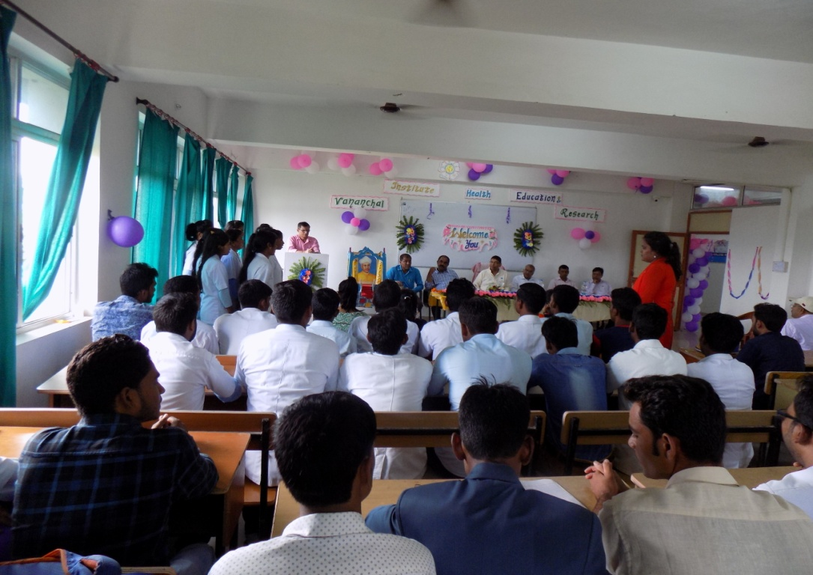

Personality and professional development:

For Personality and Professional Development of BHMS student the DMHMCRH organizing health camps; which helps students to get hands on experience and become professionals in their carrier.

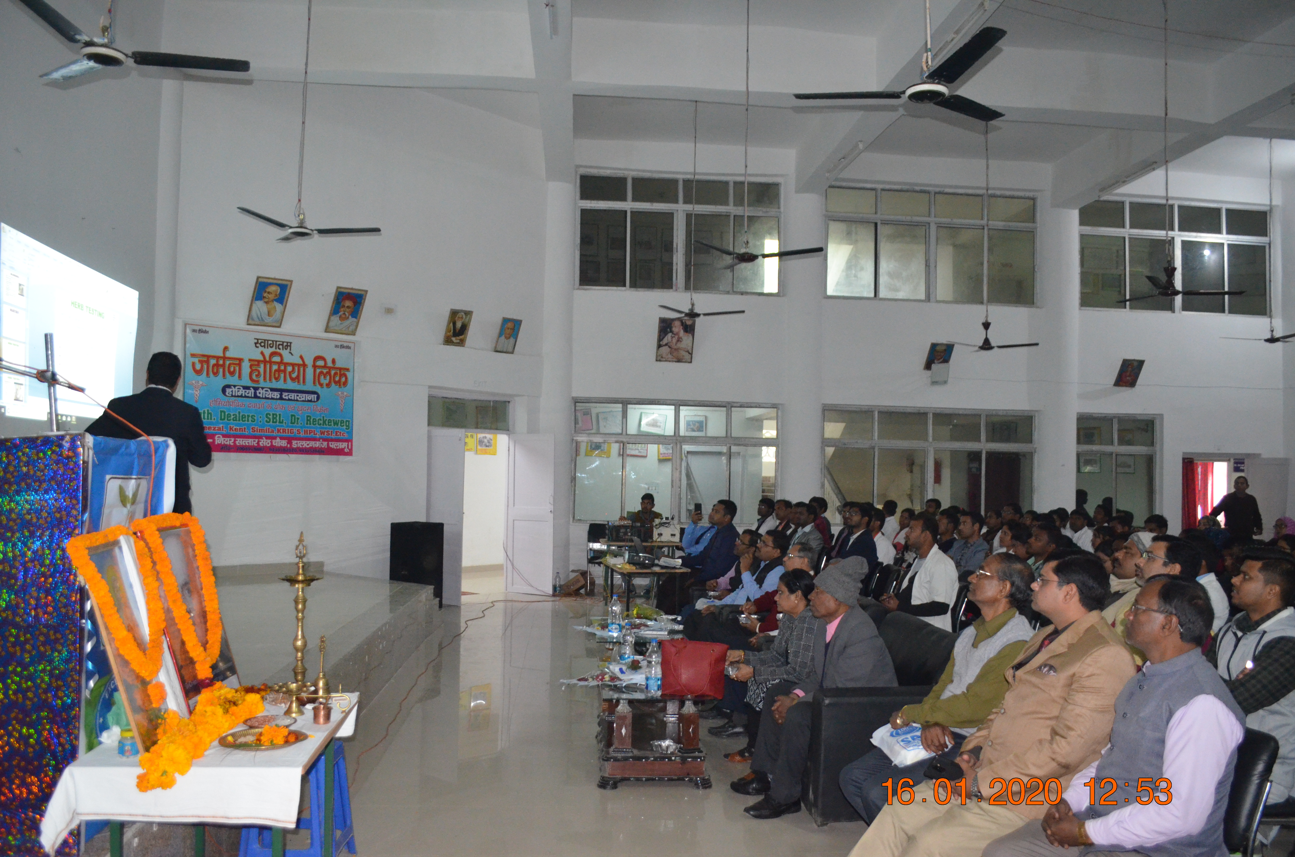
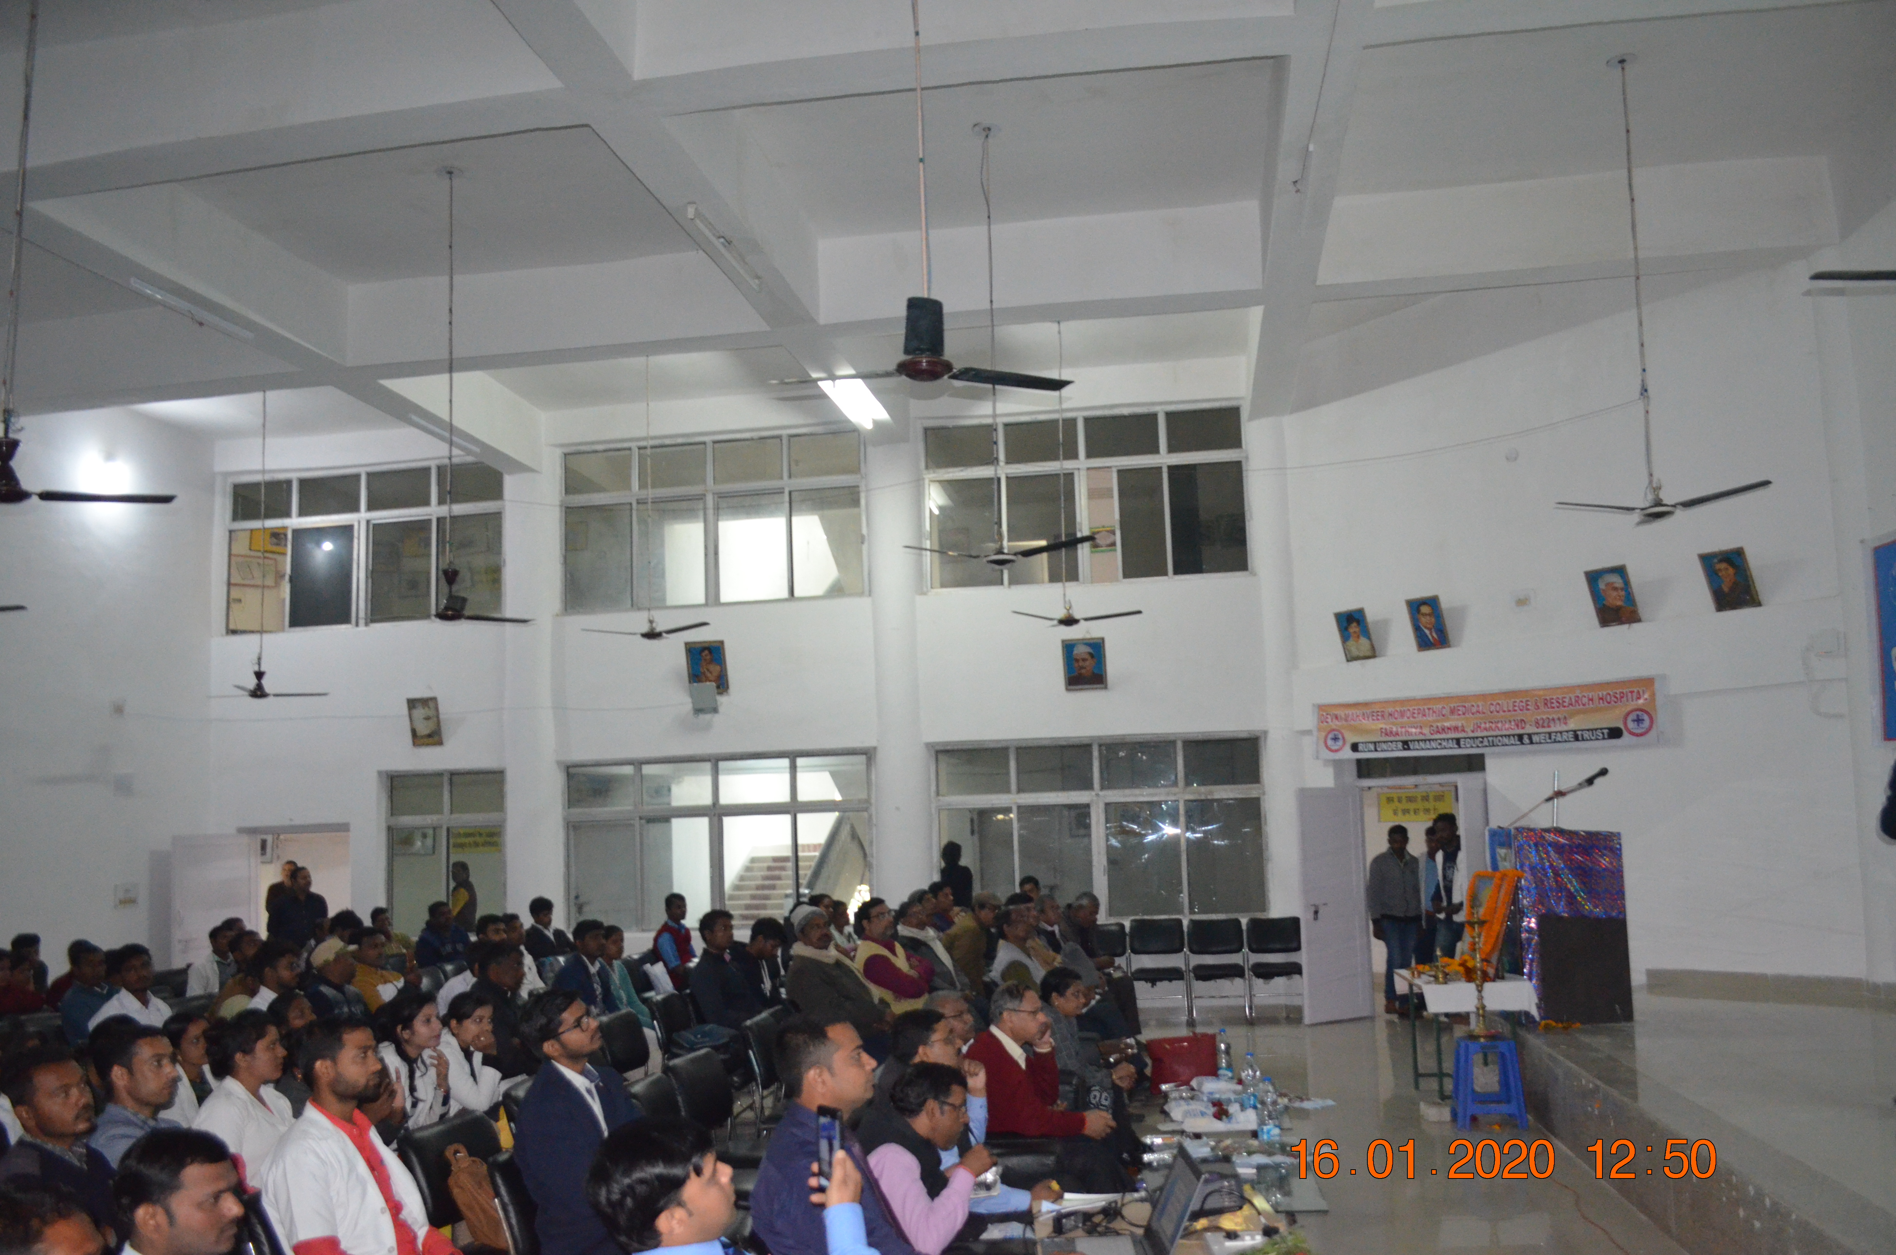

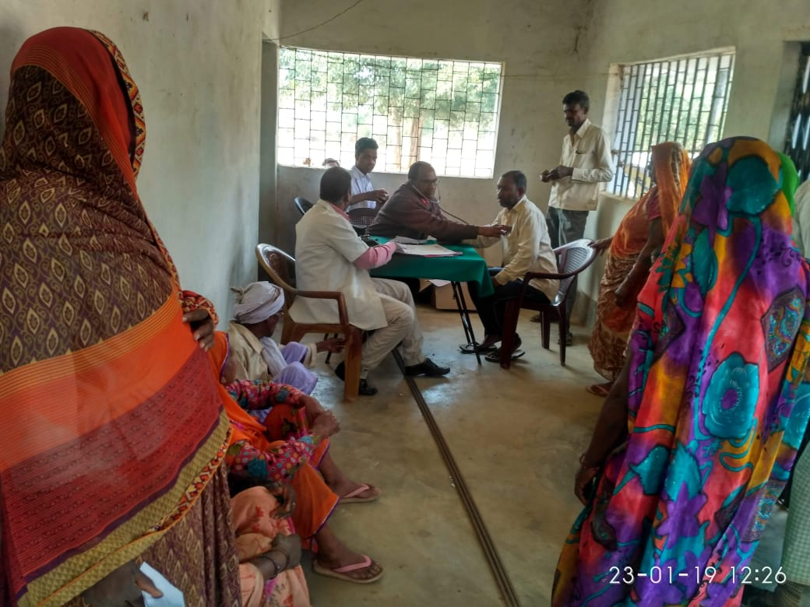

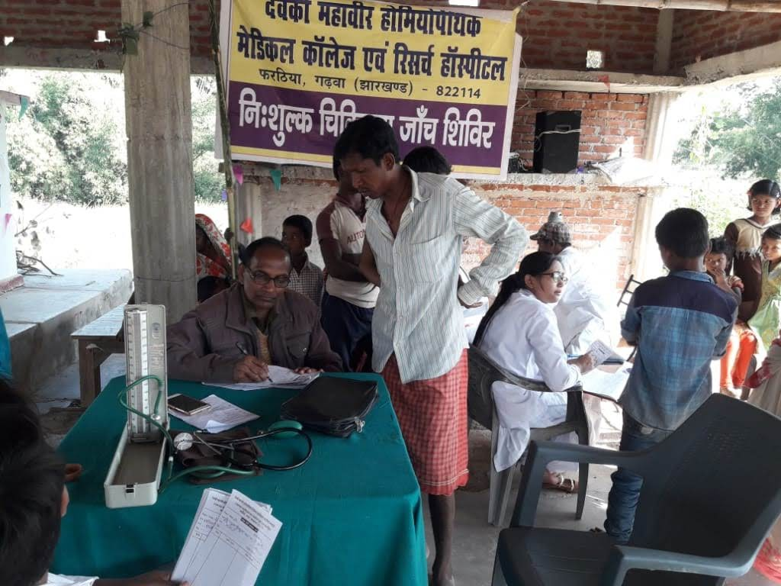

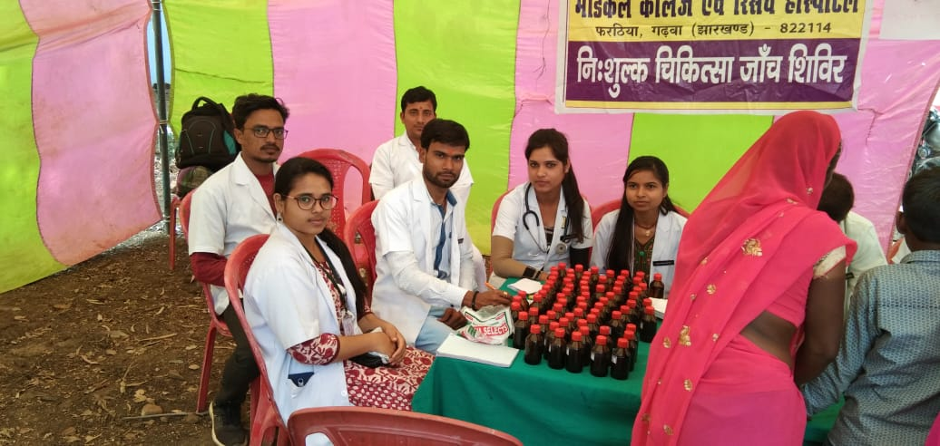

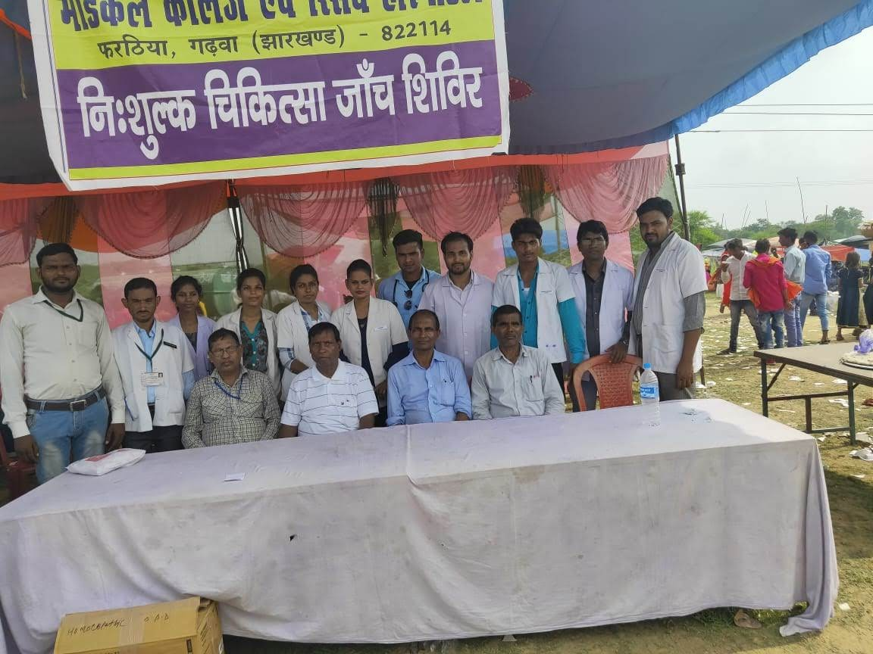

Employability skill development
  - The institution provides avenues for the students and alumni to improve their employability skills by providing them training in all the required clinical procedures thereby making them competent enough to handle their respective clinics
  - The institution also engages students in internship programs at Govt SADAR Hospital to have a better outlook of the clinical set-up thus improving their employability skills.
